Ideation Phase

Define the Problem Statements

Date | 03 Nov 2025
Team ID | NM2025TMID04510
Project Name | Calculating Family Expenses Using ServiceNow
Maximum Marks | 4 Marks

Customer Problem Statement Template
Manual procedures or disjointed records make it difficult for families to keep track of, classify, and analyze daily and overall spending. Errors, missed entries, and a lack of financial knowledge result from this. Families could go over budget, overlook crucial spending trends, or find it difficult to provide timely financial reports without automated solutions. To improve decision-making and household financial health, a system that automates spending computations, classifies entries, and provides user-friendly reporting is required. Tracking and managing both individual and overall spending will be made easier with the use of diagrams and simple workflows.
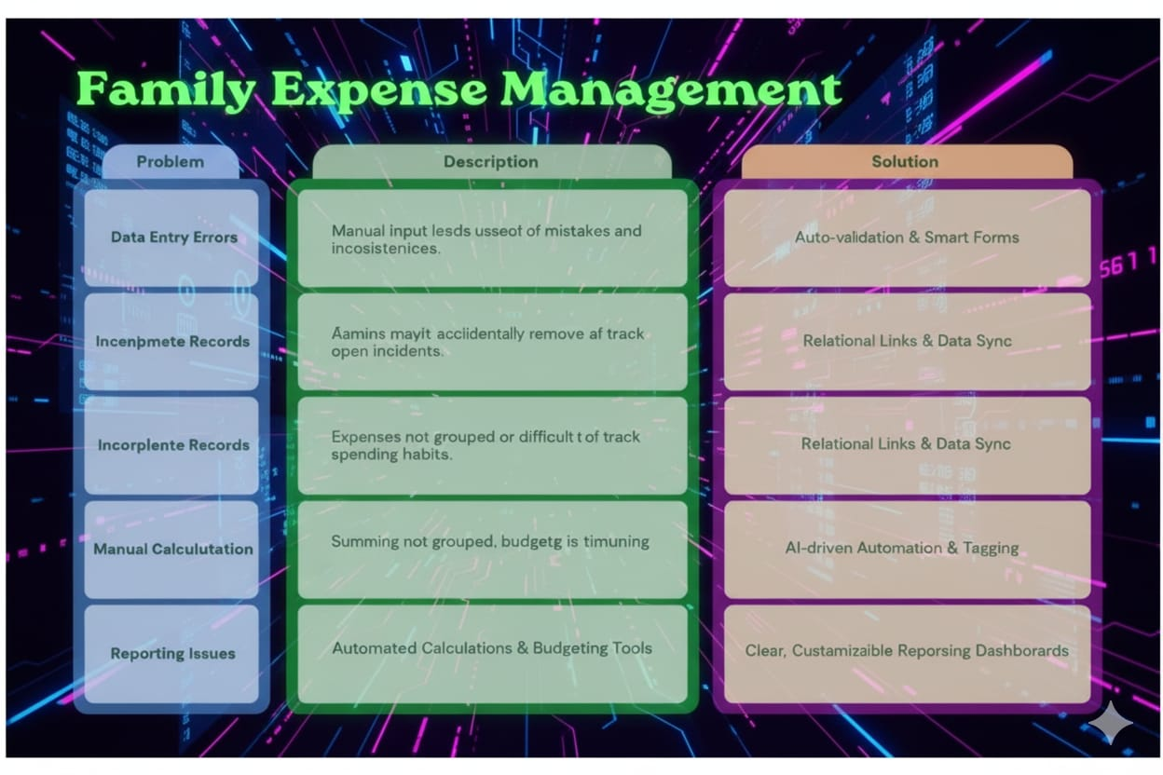
PS | I am | I’m trying to | But | Because | Which makes me feel
PS- 1 | a Family Member | Record daily expenses | the process is manual and error-prone | expenses are easily missed or  miscalculated | worried and confused
PS- 2 | a Parent | Track total family spending | records are  scattered and not linked | daily entries don't roll up clearly to totals | frustrated and uncertain
PS- 3 | a Student | Review expense trends | reports require lots of manual effort | there’s no automatic categorization or  summaries | overwhelmed and lost

Example Problem Statements
PS-1:
As a family member, I am trying to record daily expenses but struggle with keeping
track and calculating total expenses manually. This process is time-consuming and prone to mistakes, causing frustration and confusion in managing our budget.
PS-2:
As a parent, I want to ensure that all expenses are recorded and categorized, but
without automation, data entry is repetitive, and generating accurate reports is difficult. This impacts our ability to identify saving opportunities and avoid unnecessary spending.
PS-3:
As a student managing personal expenses within my family, I often need to review
spending trends over weeks or months. Using manual or unlinked methods makes it difficult to categorize and analyze where money is going, causing me to miss important insights and feel overwhelmed by the sheer volume of data to process.

